NOTE: I have gravitated to using the JetBrains Rider IDE on my Mac (as Visual Studio for Mac is being discontinued), so the Test Explorer looks a little different than in my earlier labs.

All Tests

Test Add Batch:

Test Get Brew History

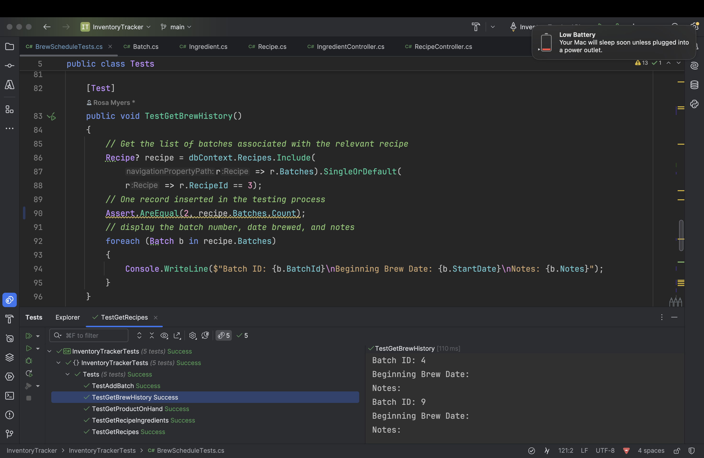

Test Get Product On Hand (none currently)

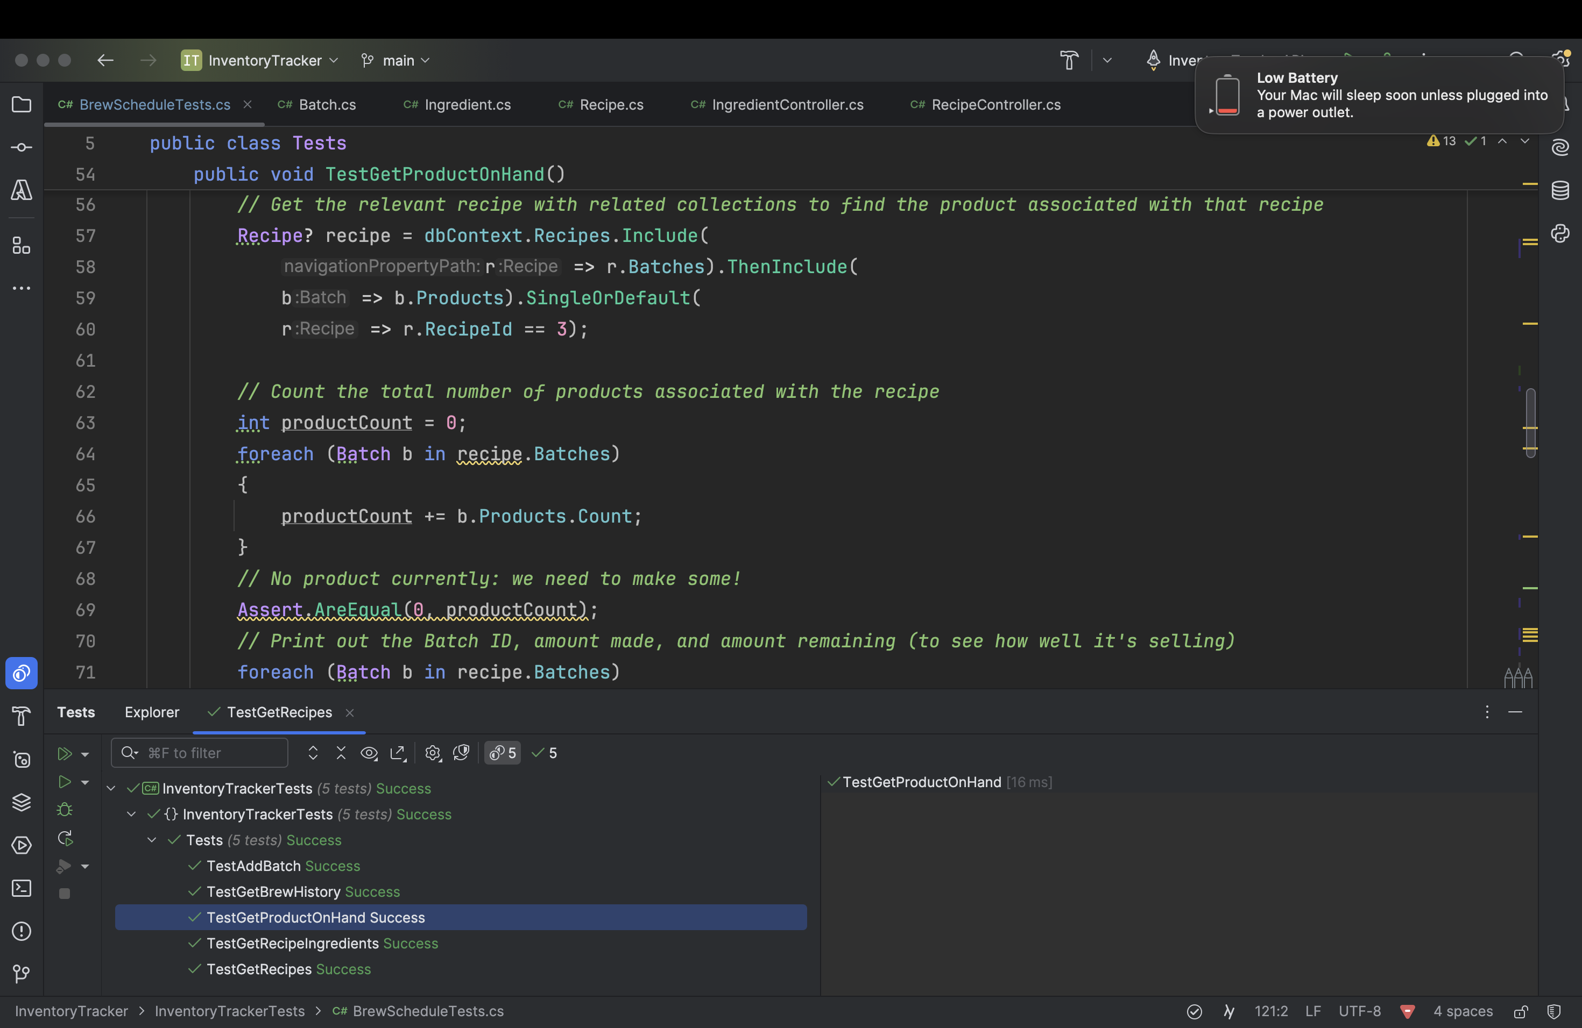

Test Get Recipe Ingredients (using several Include statements)

Test Get Recipes

